Toyota Tacoma Steering Rack Bushing Replacement
Vehicle Information: 1996 Toyota Tacoma
These are basic instructions on how to replace the stock steering rack mount bushings. Use this information AT YOUR OWN RISK.
If you have any questions about this write-up visit: www.lieblweb.com
Troubleshooting: I was experiencing some 'rubbing' or 'shuddering' sounds at tight turns. With stock tires and 1.5" of lift, I knew I wasn't rubbing on anything. One day I decided to lift up the front end of the vehicle and take a look. I didn't notice anything out of the ordinary at first. I proceeded to grab a wheel and move it side to side. I noticed the entire steering rack was moving back and forth. I took a closer look and saw some wear marks (clean metal) on the outter edges of the passenger side rack bushing. At that time, I knew exactly what I had to do - replace the bushings that help support the rack in place. You can order Energy Suspension Rack & Pinion Bushing Set Part # 8-10101 from Suspension Restoration Parts Co. for $13.00 (click link for ordering information) -also available from other retailers.

SAFETY FIRST | - Place the vehicle on a level surface, put the parking brake on and make sure the vehicle is in gear.  - Jack up the front of the vehicle (both sides at the same time) using a hydraulic jack (or other lifting device) on the center of the crossmember. If you look at your skid plate, you can see a rounded indentation where the jacking point is. Support the vehicle with jack stands on the frame at both sides. Make sure the front wheels are off the ground.
REMOVAL | - Remove the rear portion of the skid plate.
REMOVAL | - Disconnect the sway bar at both sides.

Discription: Below you will see a picture of the power steering rack. This picture will show you the mounting points AND the places where the bushings are to be replaced.
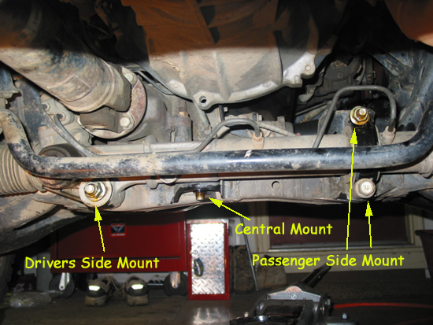

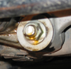  Drivers Side Mount | This mount is a LONG bolt (about 10 inches) that goes through the rack and through the cross member. You'll see the head of the bolt on the other side of the cross member. We used 1/2" ratchet with 22mm socket and a long pipe for leverage. These things are TIGHT. Start off by getting this bolt loose - DO NOT REMOVE YET!
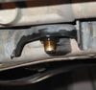  Central Mount | This mount is one single bolt that goes in through the top. This is the most difficult bolt to get out because of the clearance at the bolt head. Size is 19mm. Start off by getting this bolt loose - DO NOT REMOVE YET!
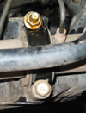  Passenger Side Mount | At the top is a stud welded to the cross member - you remove the nut. At the bottom is a bolt threaded into a nut that is welded on the cross member. The outer 'saddle' bracket (grommet) comes off completely. Size 19mm. Start off by getting this bolt loose - DO NOT REMOVE YET!

Safety: | We used 2 straps wrapped loosely around the steering rack and up on the upper a-arms for safety purposes.
Removing Hardware: | After you've managed to get all the bolts lose - start removing all the mounting hardware. *SAVE EVERYTHING!
Muscles, Muscles Muscles...... | After removing all the hardware, you have a steering rack that is almost dangling there and can be shifted in any direction (almost). The next few steps are the tricky parts......
Passenger Side Bushing | Remove the passenger side bracket and old bushing. Remember the orientation of the bracket for when you re-install.
Shifting Rack | At this time - You will begin to shift the rack in various directions. Be careful when shifting the rack - Watch to make sure you do not kink or harm any fluid lines or parts.
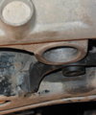  Central Mount Bushing | Have a friend help you with this - While you are underneath the rack/truck, have a friend move the wheels in and out (both sides). This will cause the entire rack to move. Keep moving the wheels and shifting the rack towards the back of the truck. Continue to shift the rack until this mount pops out of its position.  The old bushings have a metal sleeve in them. Place a socket (same diameter as the metal sleeve) up against the underside of the sleeve and strike the socket with a hammer. This will pound out the old bushing. The picture to the left - old bushing has already been removed. Clean the bushing surfaces before applying the new bushings.
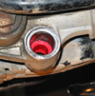  Central Mount Bushing | Take notice to the old bushing - there is a metal washer on the inside next to the cross member. This metal washer and the metal sleeve in the bushing are all one piece. Using the same method as you used for the central bushing, pound this bushing out but towards the cross member. You may need to muscle/shift the steering rack in order to get the old bushing completely out.
Installation of Central Bushing | In the bushing kit - you'll see a pair of short round bushings and a metal sleeve that goes with them. This metal sleeve is not the right size to accommodate the stock hardware. You will need to drill (or mill) the center of the metal sleeve with a 9/16" drill bit or mill. You should be able to slide the stock bolt inside the metal sleeve easily.  After drilling the metal sleeve, install both halves of the bushing and pound or press the metal sleeve in. Make sure the metal sleeve is flush or slightly below the level of the new bushing.
Installation of the Drivers Side Bushing | Next, you'll find a pair of round bushings and another metal sleeve. This sleeve should be the right size to accommodate the LONG bolt. The kit also supplies a new washer.  Install both halves of the bushings in the rack. Pound or press the metal sleeve inside the bushing.
Installation of the Passenger Side Bushing | This bushing is self explanatory and the easiest to install.
Getting it all back together.... | The first thing you want to do is shift the rack (like before) to get the central bushing mount back up and in its mounting point. Don't worry about getting the bolt holes lined up. All you need to do is get it up and inside that shelf slightly.
Next.... | The Passenger side bracket can be put in place over the new bushing. Attach the nut and bolt but do not tighten too much.
Then..... | Slide the LONG bolt through the cross member - place a washer (either old or new) in between the cross member and the rack - push the LONG bolt through the rack (and washer) entirely. If you're really lucky...you'll have enough bolt coming through to add the last washer and attach the nut by a few threads.  Begin tightening this nut.... This will help PULL the rack in place and help line up the holes on the central mount. As the nut is harder to tighten, alternate between the passenger side mount and drivers side mount tightening each bolt/nut tighter each time. YES - the drivers side bushing will squeeze out of its normal shape.
Finally..... | Keep checking to see if the central mount holes are lined up - and slide the bolt through it. When all hardware is attached....torque to Toyota required specifications:  Passenger Side Mount bolts 123 ft lbs  Central Mount 123 ft lbs  Drivers Side Mount 141 ft lbs
Clean Up... | Install your skid plate back on, lower the vehicle, and clean up all your tools. GREAT JOB!!

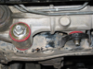  Drivers side Completed | 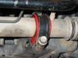  Passenger side Completed | 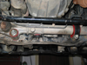  Full Rack Complete

